# Manor Farm Nurseries User Registration Process

## Step 1

You should receive an email that lets you know that a user has registered. When you get this you should log in to the website. If you do not want the user to be registered, follow the process and find the user and then click on the DELETE link to remove them.

## Step 2

Once logged in go the to administrator dashboard by selecting the Dashboard sub menu when you hover over the black Manor Farm Nurseries name in the top left corner of the screen.

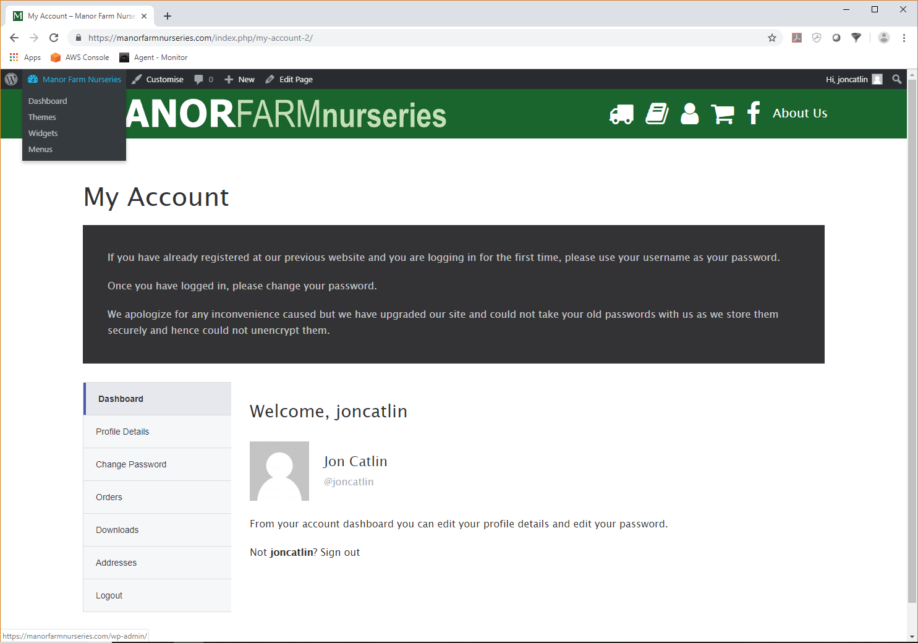

## Step 3

Click on the Users menu item in the black menu on the left of the screen. In the drop down labelled All approval statuses, select Pending and then click on the filter button by the side of it.

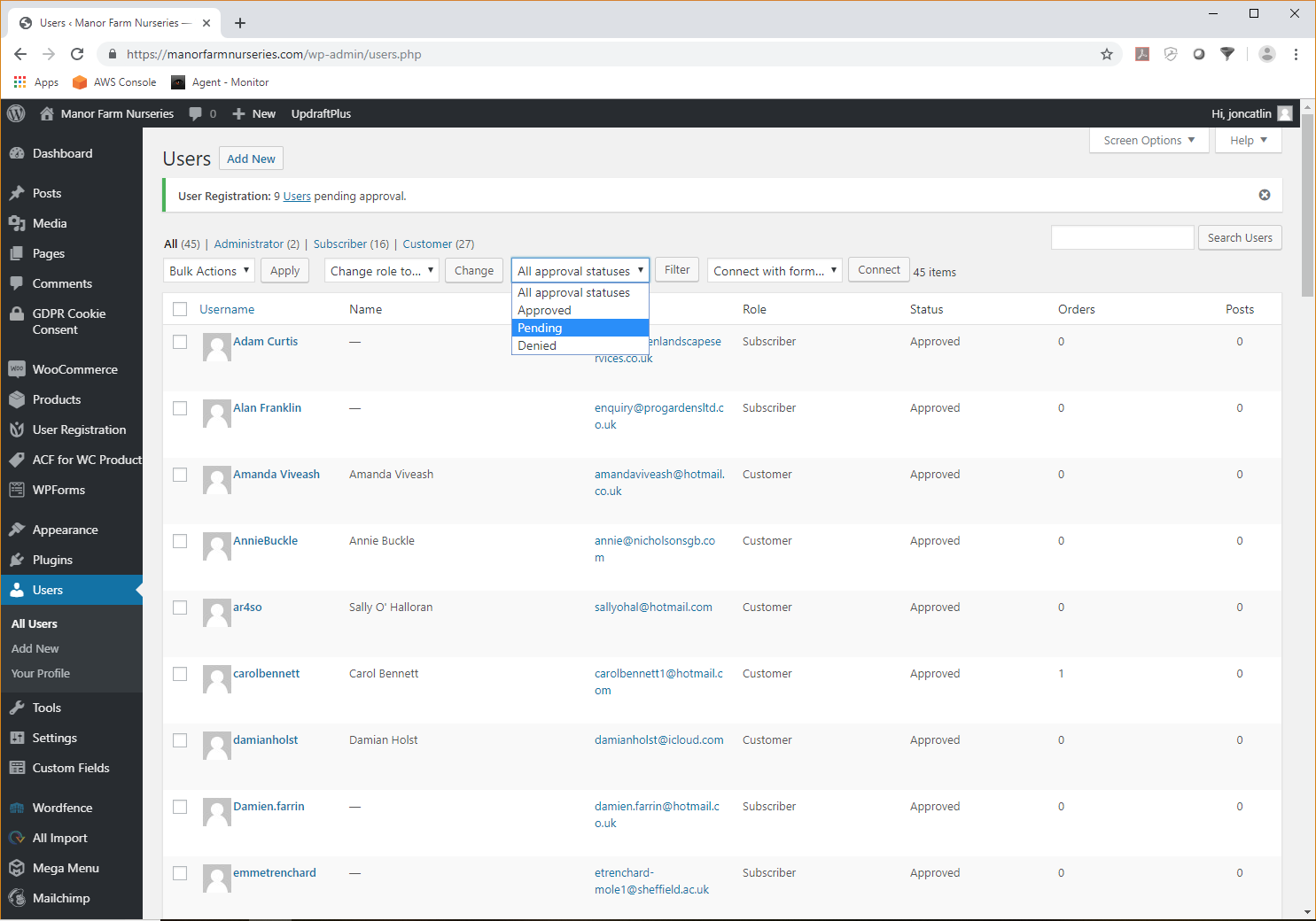

The screen should refresh and only show the users who are waiting for your approval before they can be registered.

## Step 4

For each users you want to approve, select the user by clicking on their username. The screen should change to one similar to the picture below.

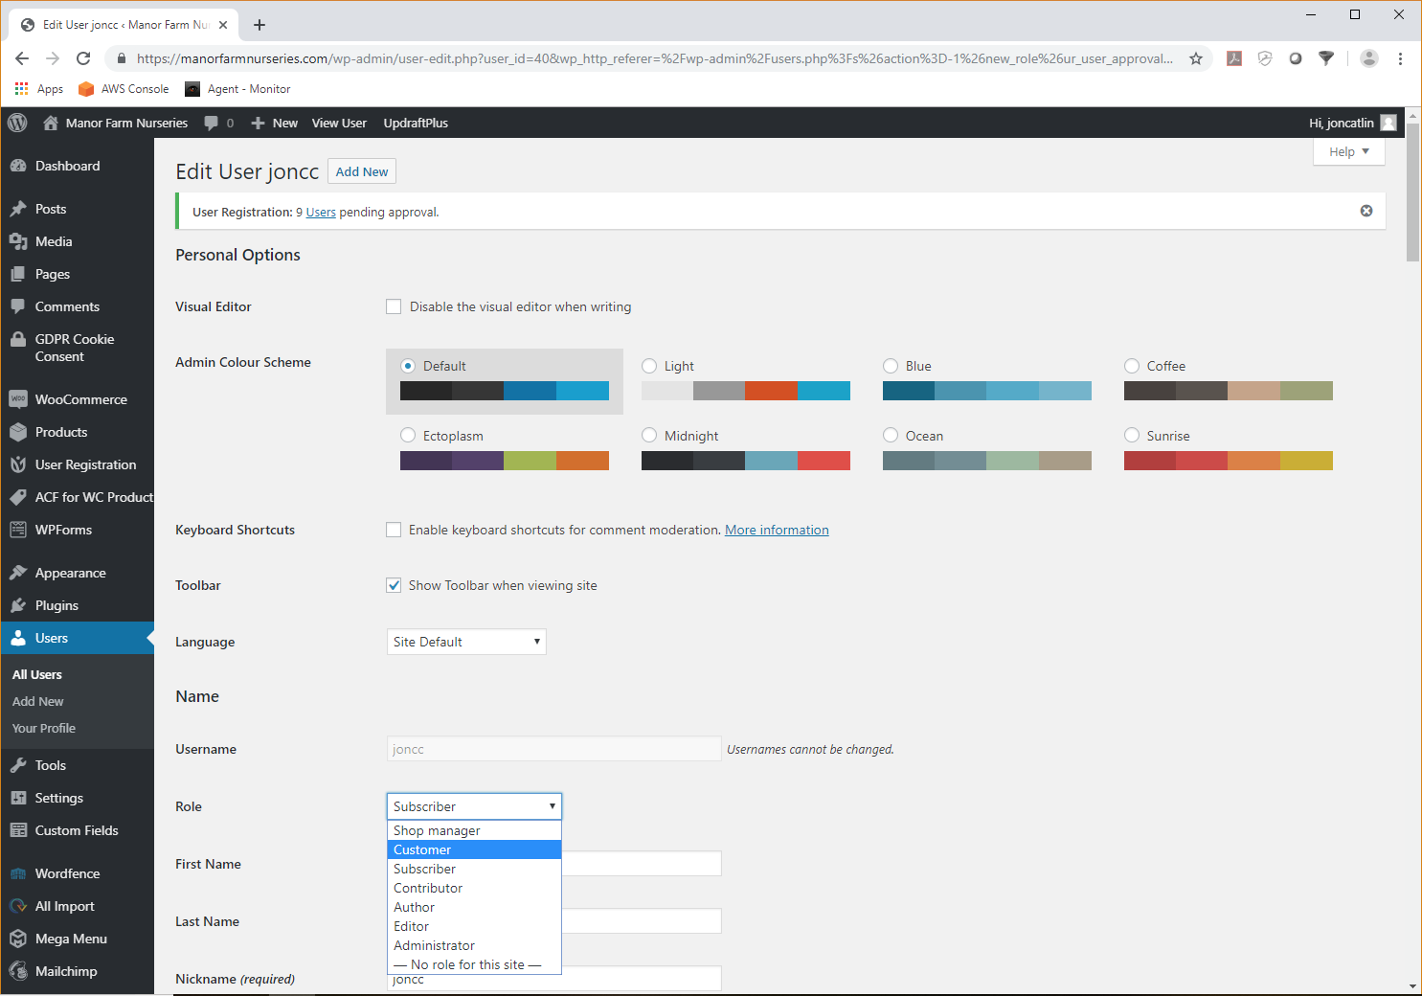

You MUST do both of the following things. First in the Role drop down select Customer. This role is required for the user to see prices.

Then scroll down the screen to you see the Approval Status and select Approved.

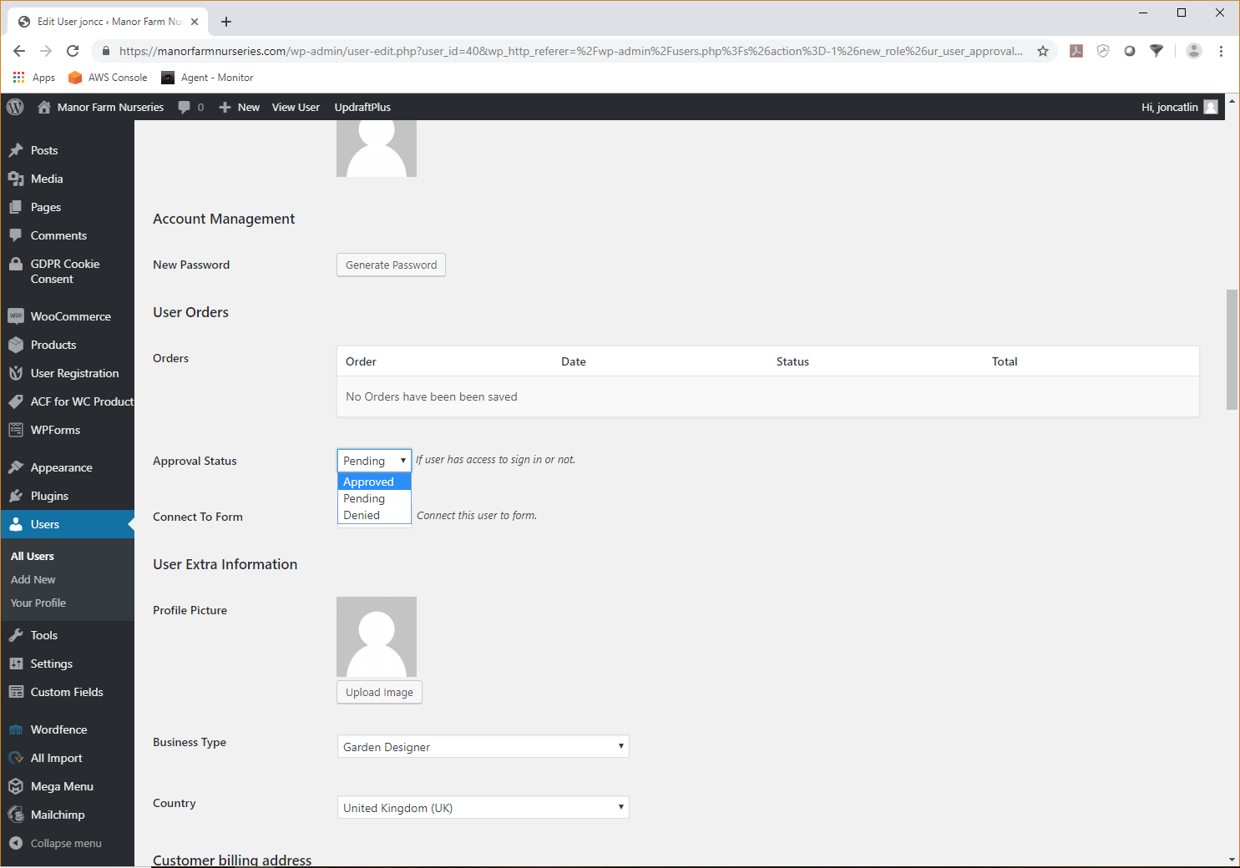

Then scroll to the bottom of the screen and click on the button marked Update User. This will save the changes. Be sure to make BOTH the role change to Customer and the status change to Approved, otherwise the users experience will be wrong.

## Step 5

No repeat the process by going to step 3 again for the next user. Once you have done this for all pending users you are done!